Lab 23 - Build and Operate Container

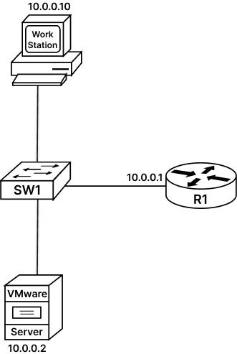

Task 1: Operating Container:
CONTAINERS: Containers are instances that run on a host (bare metal or virtual machine). They do not require Operating Systems and are only created to run a specific process or application.
Containers are made using kernel features of the host OS and layered file system to set them aside. They only have necessary components that are required by the applications.
Users can start/stop containers as required. Containers only consumes resources that are required for application to run.
Containers are stored as small portable images, that makes them ready to use applications that runs the same regardless to where it is, as long as the host system runs containers.
Docker and Kubernetes are container management technology used to create, manage, and monitor Linux containers. Ansible is also Container-management system used by Red Hat
LAB SCENARIO: Web hosting application is downloaded from “hub.docker.com” site and stored in the form of image in local repository of Docker installed on our machine.
We have created a web page in the Public-html directory of our machine which need a web hosting application to host this page.
We will use the recently downloaded Web hosting application to host this web page and we want to run this application in a container allocated with compute resources. To achieve this,
- we will have to create a Docker configuration file (DockerFile) that will map the web page to the Web hosting application. This Docker configuration will be used to build a container image.
- Now with this container image we will run a Container and allocate it with desired compute resource to host our web page.
- Docker DHCP service will assign an IP address to this container that will be used to access the web site.
Step 1: Start Terminal window on Ubuntu host Operating System by clicking the Terminal icon.
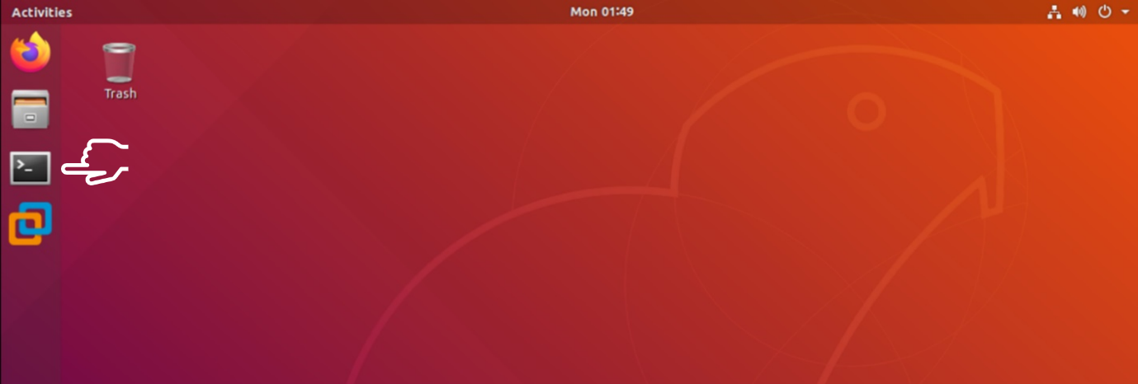
Step 2: A web hosting application (httpd) is downloaded from “hub.docker.com” site and stored in the form of image in local repository of Docker that can be verified using command “sudo docker images”
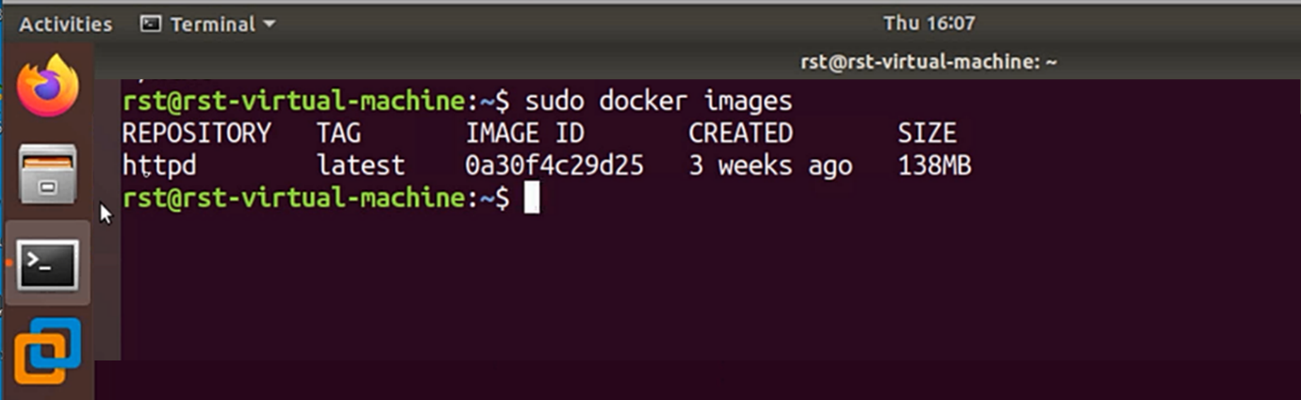
Step 3: A web page has been already created in the Public-html directory of our machine which can be verified using command “cat public-html/index.html”
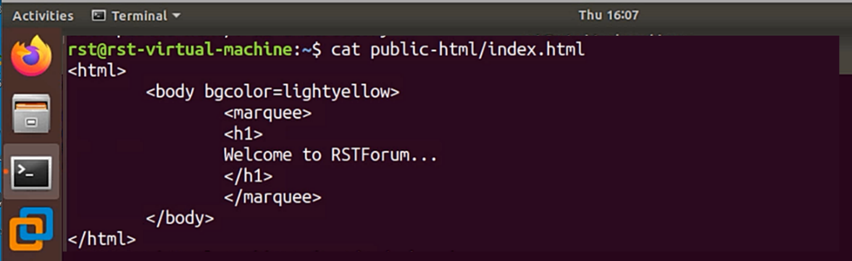
Step 4: Create a Docker configuration file (DockerFile) to map the web page to the Web hosting application “httpd”. This file is already created on your system which can be verified using the command “cat DockerFile”
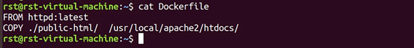
Step 5: Now let us build the Container image using Docker configuration file and name this image as mysite using command “sudo docker build -t mysite . “
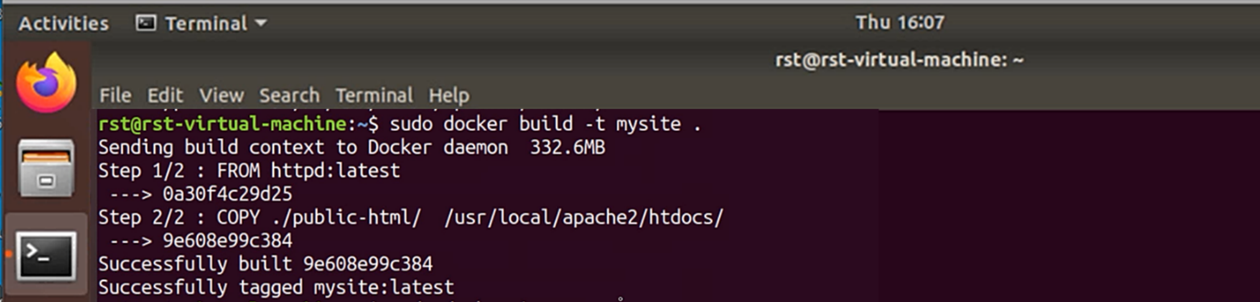
Step 6: Now with this container image we will run a Container and allocate it with desired compute resource using command “sudo docker run -p 80:80 - - memory=128MB - - cpus=1 mysite” .
This command will start container and Docker DHCP service will assign an IP address to this container that will be used to access the web site.
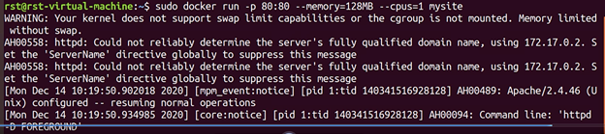
As seen in the figure above, you have been assigned an IP address 172.17.0.2 for your container. Use this IP address to access your web page.
Step 7: Go to Browser and type http://172.17.0.2 check if the portal is up and running.
